**ITE3714: Multimedia Website Design Practices**

# **Lab 3 – Anchor and Tables in HTML**

1. Create a folder named **lab3** in Desktop
2. Download **"lab3_student.zip"** from Moodle
3. Unzip **"lab3_student.zip"** and put it in folder **lab3**
4. Open **"lab3_student.html"** using Notepad++ and Google Chrome
5. Add a pair of <a> tag in the following text

**CW**

**LWL**

**ST**

**TY**

**TM**

|  |
| --- |
| <a href="#cw">CW</a>  <br><br>  <a href="#lwl">LWL</a>  <br><br>  <a href="#st">ST</a>  <br><br>  <a href="#ty">TY</a>  <br><br>  <a href="#tm">TM</a> |

1. Add a pair of **<a>** tag and **<font>** tag in the following text

**IVE(CW)**

**IVE(LWL)**

**IVE(ST)**

**IVE(TY)**

**IVE(TM)**

|  |
| --- |
| <a name="cw"><font size="5" color="Navy">IVE(CW)</font></a>  …  <a name="lwl"><font size="5" color="Navy">IVE(LWL)</font></a>  …  <a name="st"><font size="5" color="Navy">IVE(ST)</font></a>  …  <a name="ty"><font size="5" color="Navy">IVE(TY)</font></a>  …  <a name="tm"><font size="5" color="Navy">IVE(TM)</font></a> |

1. Use **<table>**, **<tr>** and **<td>** tag to create a table for Chai Wan Campus

|  |
| --- |
| <table border="0">  <tr bgcolor="Yellow"><td>Address: </td><td>30 Shing Tai Road Chai Wan, Hong Kong</td></tr>  <tr bgcolor="#00CCCC"><td>Tel: </td><td>2595 8333</td></tr>  <tr bgcolor="Yellow"><td>Fax: </td><td>2505 4200</td></tr>  </table>  <br><br> |

1. Use **<table>**, **<tr>** and **<td>** tag to create a table for Lee Wai Lee Campus

|  |
| --- |
| <table border="5">  <tr><td colspan="2" align="center">Lee Wai Lee Campus</td></tr>  <tr><td>Address:</td><td>3 King Ling Road Tseung Kwan O, New Territories</td></tr>  <tr><td>Tel:</td><td>Tel: 3928 2000</td></tr>  <tr><td>Fax:</td><td>Fax: 3928 2024</td></tr>  </table> |

1. Use **<table>**, **<tr>** and **<td>** tag to create a table for Sha Tin Campus

|  |
| --- |
| <table border="1">  <tr><td colspan="3" align="center">Sha Tin Campus</td></tr>  <tr><td>Address:</td><td>21 Yuen Wo Road, Sha Tin, New Territories</td>  <td rowspan="3"><img src="st.jpg" width="300" height="200"></td></tr>  <tr><td>Tel: </td><td>2606 6227</td></tr>  <tr><td>Fax: </td><td>2694 7029</td></tr>  </table> |

1. Use **<table>**, **<tr>** and **<td>** tag to create a table for Tsing Yi Campus

|  |
| --- |
| <table border="1">  <tr><td colspan="3" align="center">Tsing Yi Campus</td></tr>  <tr><td>Address: </td><td>20 Tsing Yi Road, Tsing Yi Island, New Territories</td>  <td rowspan="3"><img src="ty.jpg" width="300" height="200"></td></tr>  <tr><td>Tel: </td><td>2436 8333</td></tr>  <tr><td>Fax: </td><td>2434 5652</td></tr>  </table> |

1. Use **<table>**, **<tr>** and **<td>** tag to create a table for Tuen Mun Campus

|  |
| --- |
| <table border="1">  <tr><td colspan="3" align="center">Tuen Mun Campus</td></tr>  <tr><td>Address: </td><td>18 Tsing Wun Road, Tuen Mun, New Territories</td>  <td rowspan="3"><img src="tm.jpg" width="300" height="200"></td></tr>  <tr><td>Tel: </td><td>2463 0066</td></tr>  <tr><td>Fax: </td><td>2454 5654</td></tr>  </table> |

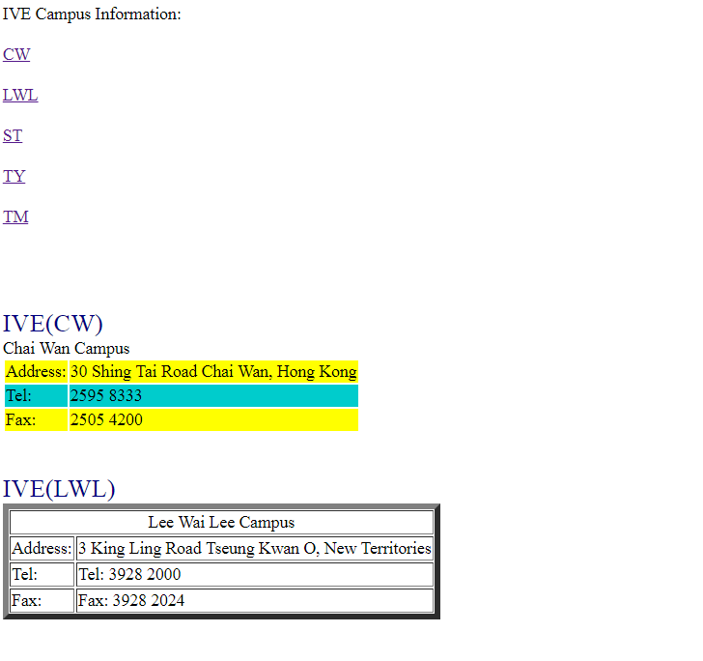

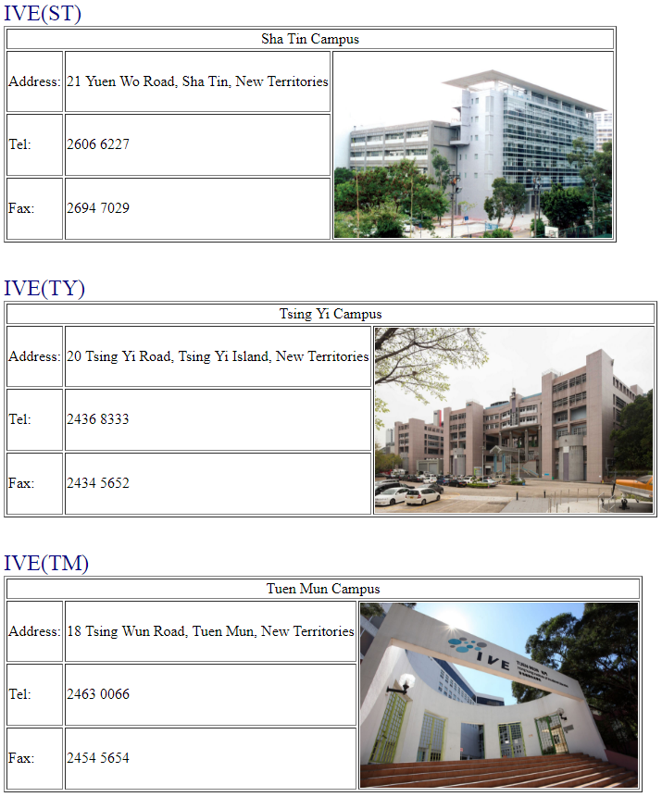

Source Codes for Reference:

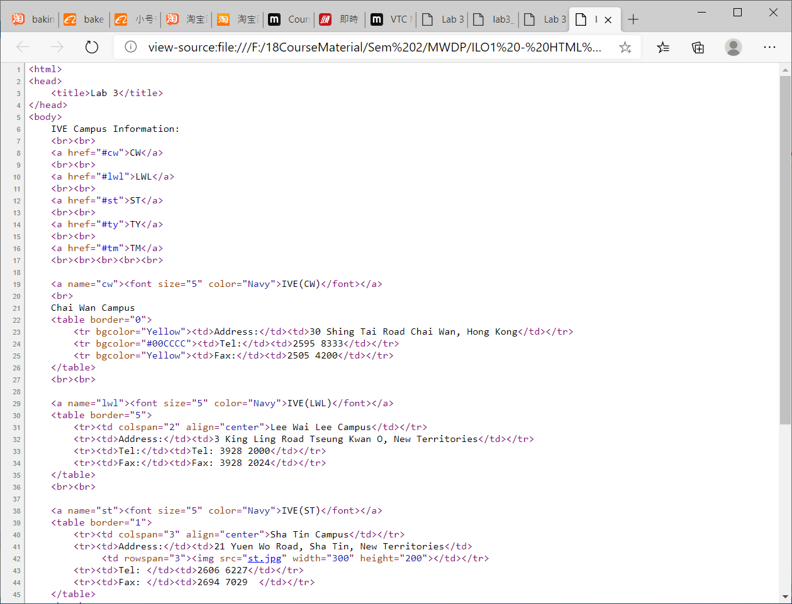

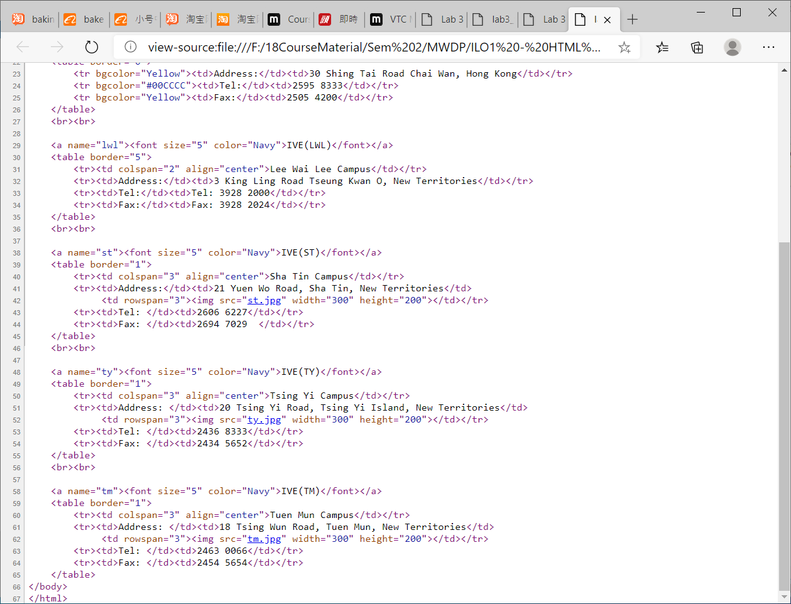

Challenge:

1. Add a line “Go To Top “ at the end of the html file and then add a bookmark “top” to the first line of the html file. Once the “Go To Top” is clicked in the webpage, it will go to the Top of the page.
2. Design on your own to add the CW and LWL campus pictures in your work.